Anup Panta

Product Part

Remote interface

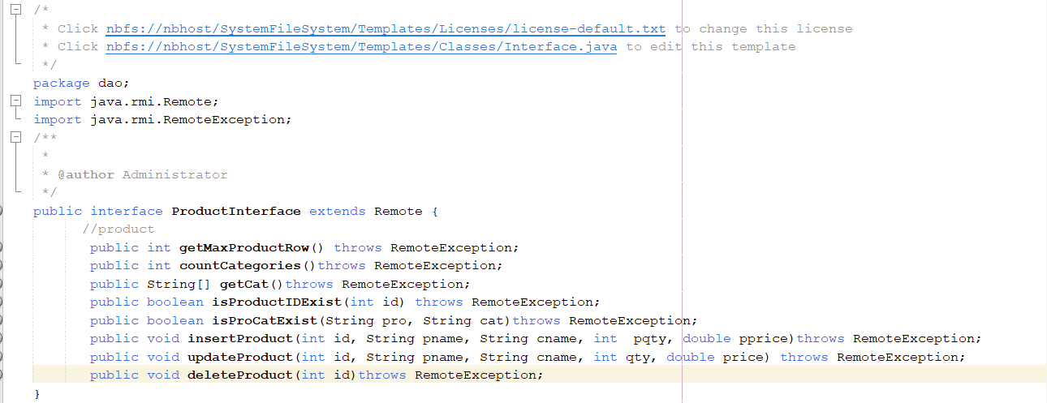

Remote Objects

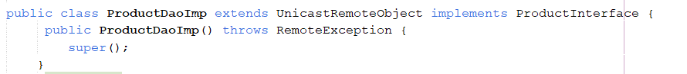

Client Program

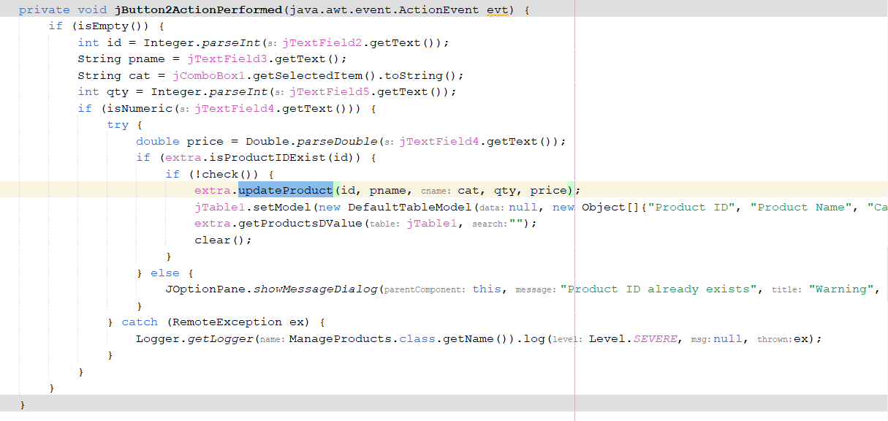

Server snippet

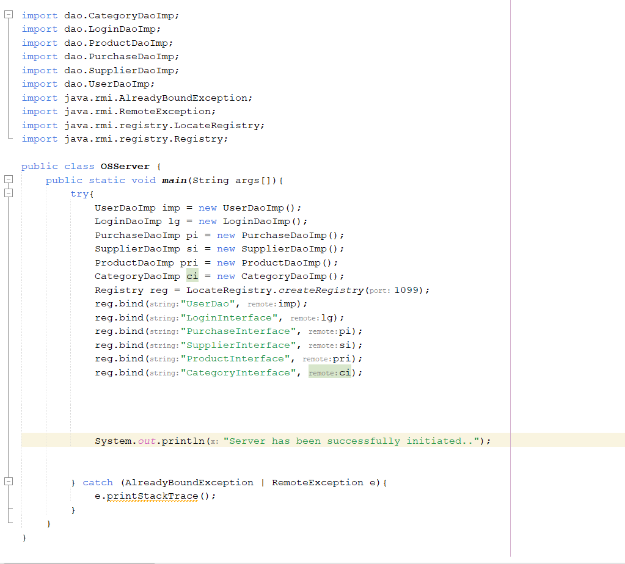

Client Snippet

